

**Platform Tech Solutions**

***Your Imagination, Our Creation***

Hoshiarpur, Punjab, India-146023

hr@platformtechs.in

Phone Number : +91-963-156-0280

Hi there,

“Greetings of the day”

Thank you for showing interest in Platform Tech Solutions. You are shortlisted as a Full-Stack Developer and if you are hired , you will get the opportunity to work with us as an intern for 6 Months.

As you are going to be a part of us , you should know **What Platform Tech Solutions does!** *Here’s the description*-

Platform Tech Solutions is a group of professionals who provide high quality, customized and customer-centric full IT solutions and support for the business problem.

Platform Tech Solutions is a web app, mobile app, custom software development company providing services to enterprises across the world and their digital marketing needs like social media marketing, email marketing, advertising campaigns, growth hacking, lead generation etc.

**Now,** we are giving you an assignment which you have to submit us as per given deadline.

**Aim:** To make a LogIn/SignUp Page

**Inclusions: 1.)** A splash-screen or a loading screen.

**2.)** A LogIn/SignUp screen

**3.)** A User Profile Screen

**Flowchart:**

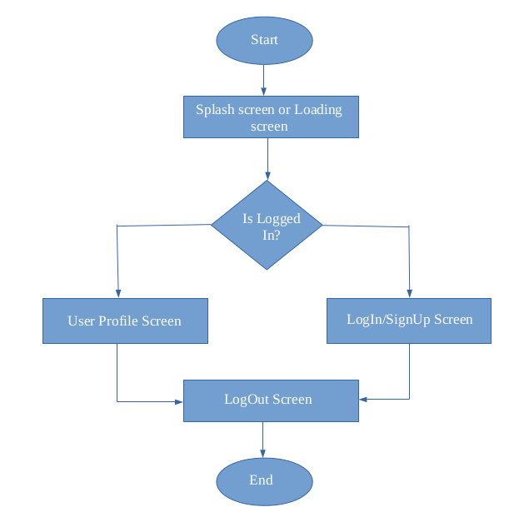

**Note: *Use Async storage for data collection and Mock-API well . It may be firebase or other.***

**Deadline:** Submit your assignment by ***3rd November, 2019, 11:59 p.m.***

**Submit At:** *hr@platformtechs.in*

Thank You

For any query, feel free to contact us.